**Project Title: IPO (Initial Public Offering)**

**Project Highlights:**

Currently for onboarding new merchants the overall process is manual which indeed consume enough resources and manpower . We want to automate the above process for onboarding new merchants.

**Technology Stack:** Java/Spring Boot

**Database: postgreSQL**

**FrontEnd Tools: HTML , CSS , Bootstrap 4**

**How this project helps end Users?**

This project will help end users to automatically on-board new merchants in IPO portal.

**Project Description:**

1. Create a front end option to Create and Approve new merchants.

2.(i) The users should be able to choose a file containing required fields and upload in the portal which will later prepopulate the fields in the frontend. NOTE: Appropriate error messages should be prompted if the user clicks on submit button without selecting any file.

2.(ii) If the user doesn’t upload the file then the fields have to been filled manually by the users.

3. Once the required fields are filled either manually by user or pre-populated by uploading a file the next step is approval. Once all the fields are approved the data should be saved in a Database and the same should be displayed in the approval tab.

4. In the approval section also show the status i.e Pending for Approval / Approved.

NOTE:-

1) VPA should be of the format either [xyzbse@axis](mailto:xyzbse@axis) or xyznse@axis.

If vpa contains word bse then it is considered as bse and we need to replace with nse and check for nse vpa availablity and vice versa.

For Example:-

1) If vpa is [xyzbse@axis](mailto:xyzbse@axis) , then replace it with [xyznse@axis](mailto:xyznse@axis) and check if it is present in the DB or not .If not then it is considered valid VPA else enter new VPA.

2) If vpa is [xyznse@axis](mailto:xyznse@axis) then check its availability in DB if not then it is a valid vpa else enter new VPA.

2) Once all the mandatory fileds (refer the image below) are supplied it should go for approval . On successful approval of the supplied fields it should be saved in the DB .

3) Appropriate Success/Failure messages should be prompted in the application where ever required.

**Example:**

Assume we have a below table with all the fields as shown:-

TBL_MERCH_ONBOARD_DTLS



Refer the below Snapshots for clear Understanding:-

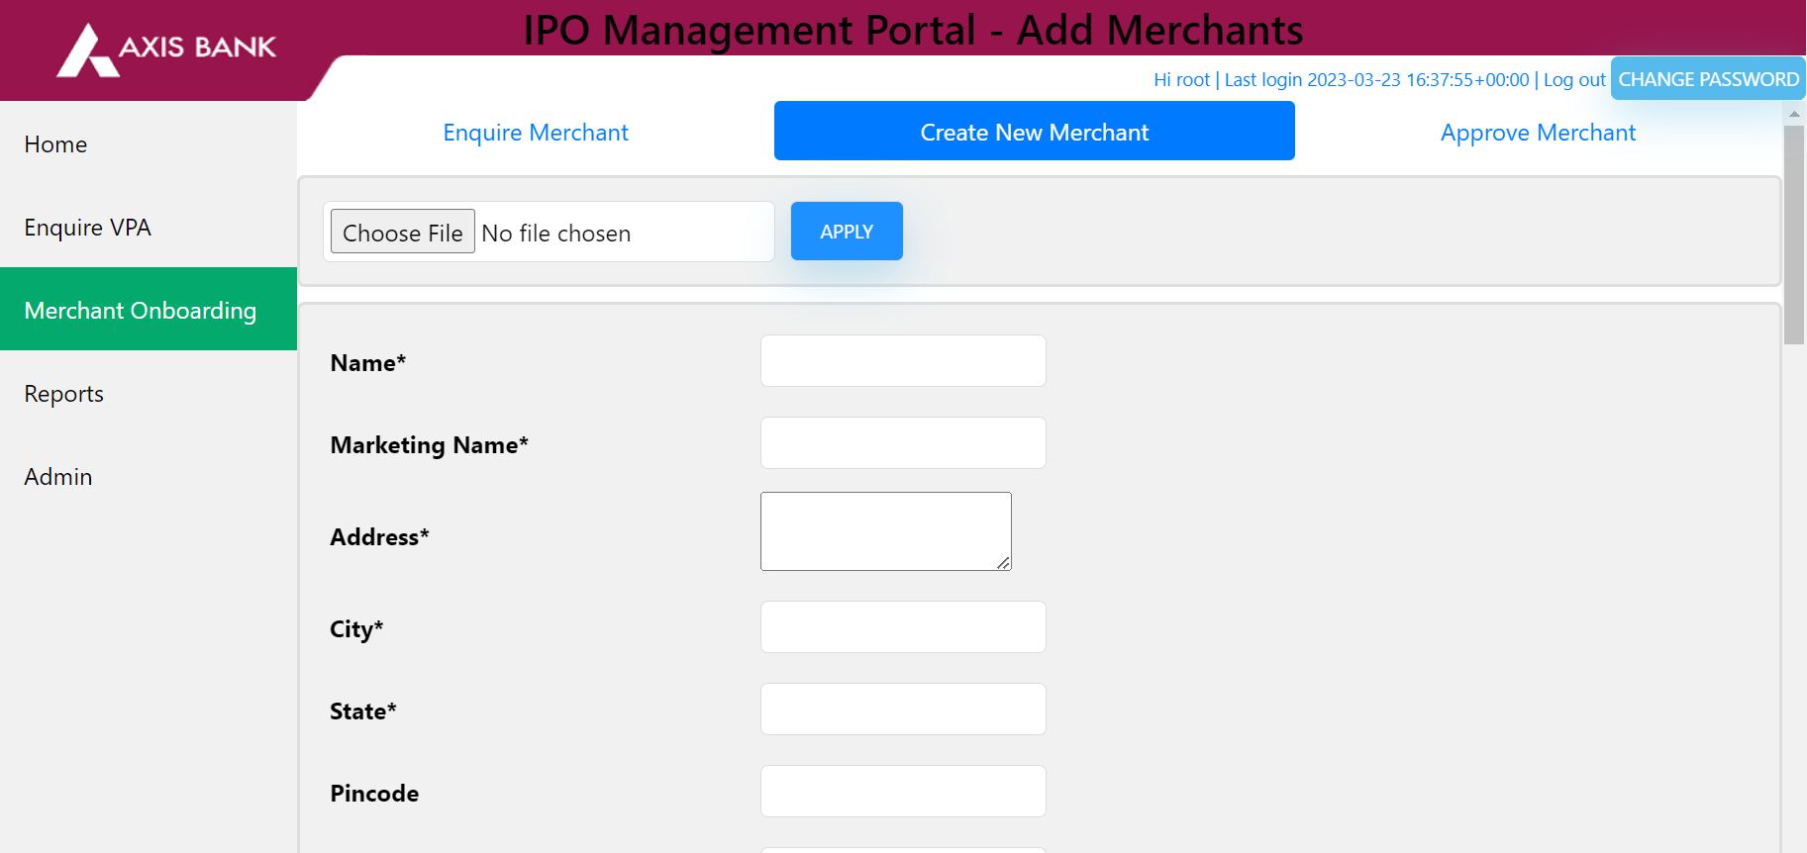

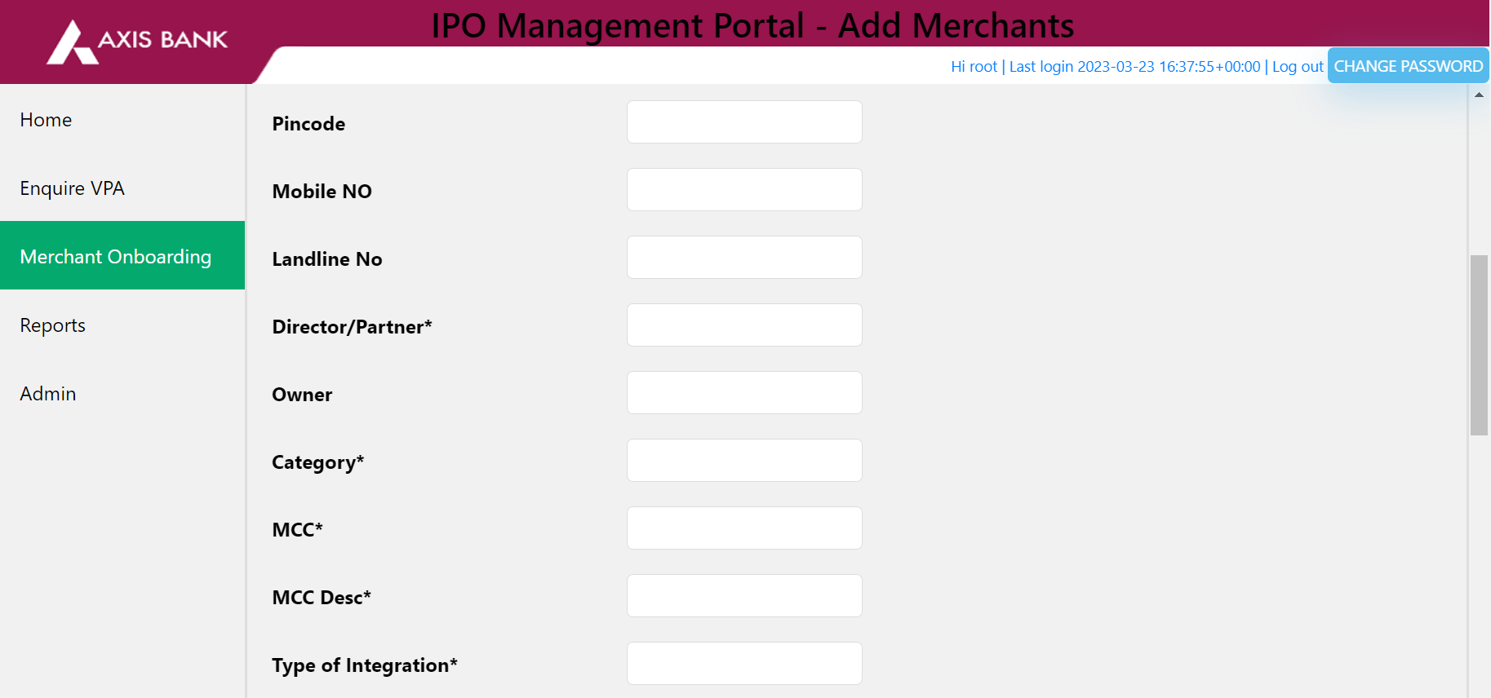

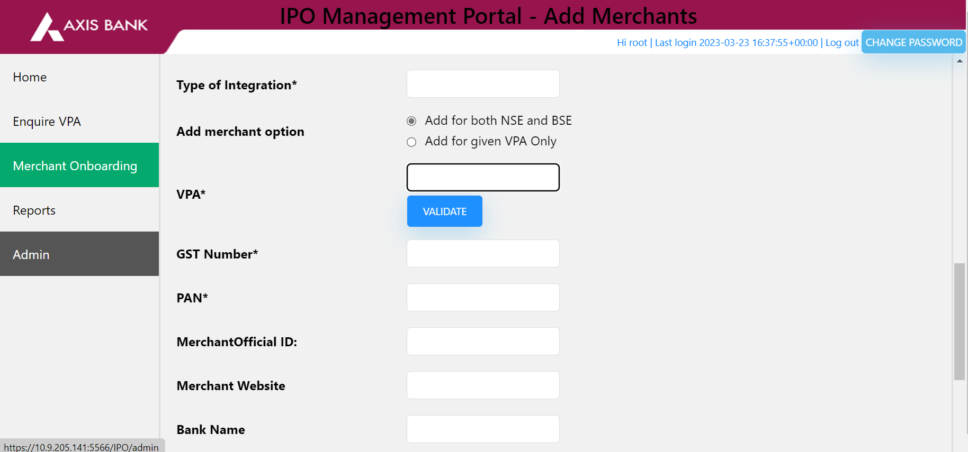

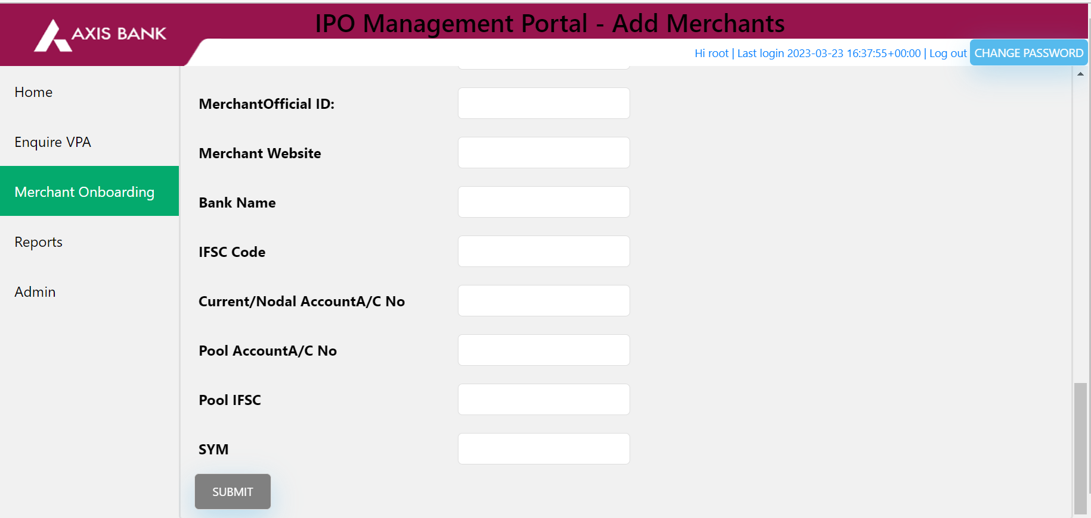

**BONUS SECTION :-**

**1) create a login page for the above application which only allows authorized users to login and modify. Appropriate error messages should be displayed on invalid user login.**